Module 1 Assignment
Miguel Fernandez
4/6/2026

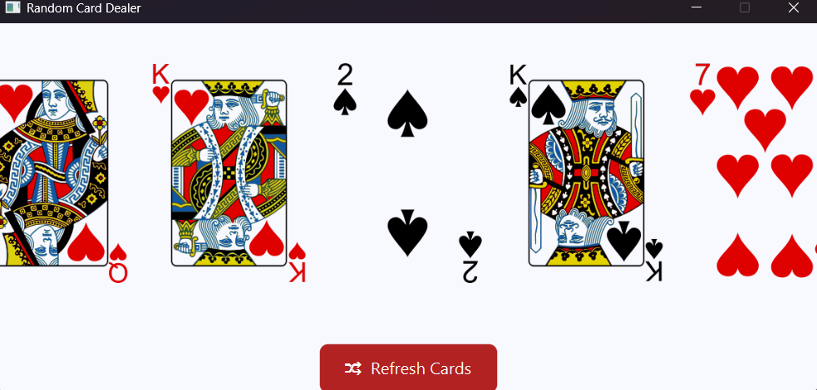

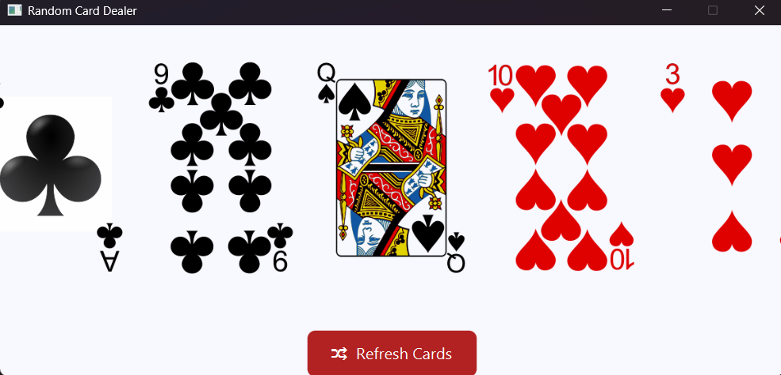

I use this repository for the cards picture: https://github.com/hayeah/playing-cards-assets
This is my repository
https://github.com/concord808030-tech/CSD420-308A-Advanced-Java-Programming-

